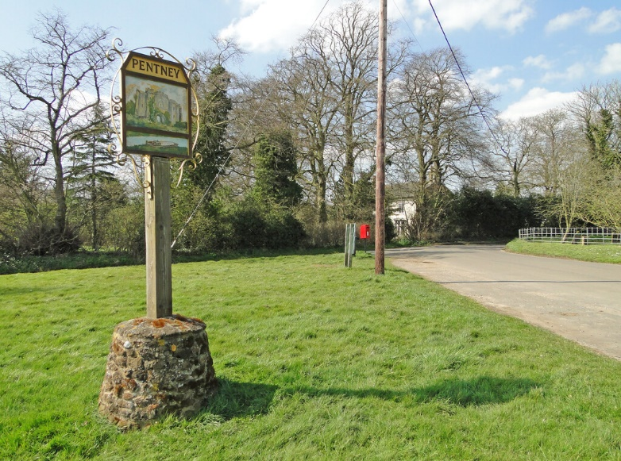
PENTNEY PARISH COUNCIL

Chairman: Cllr Kate Harvey
Clerk and RFO: Jeannine Howard
Pentneyparishcouncil@gmail.com
Mobile: 07880 858008

Annual Parish Meeting
To be held in Pentney Village Hall on 18th May commencing at 7.30pm
Agenda
Welcome by chairperson.
Reports from:
Borough Councillor
County Councillor
Police Community Officer

Reports will be welcomed from:
Local groups
Clubs
Local organisations
Etc.

All members of the parish welcome.

